MUS:4250 COMPOSITION: ELECTRONIC MEDIA I
Fall 2016
Assignment 2

- Go through your groups from Assignment 1 and do the following:
  - Use automated volume to balance the clips in each gesture.
  - Consider removing all vocal sounds, unless you want to make them the focus of your piece. In that case, use many vocal sounds.
  - With any clip that ends sharply and abruptly, consider a gentle fade out.
  - Arrange the clips so that no more than three are on Track 1, no more than three on Track 2, etc. Avoid using more than three clips on a track in each gesture. Also, avoid using empty tracks between non-empty tracks.
- Discussion of Cyclic permutations.

Group 1 Group 2
ABC => ABC
ABC => BCA
ABC => CBA
ABC => BCA
ABC => CAB
ABC => ABC

- Choose any 5 gestures, ungroup them, and arrange them in a manner similar to the example below:
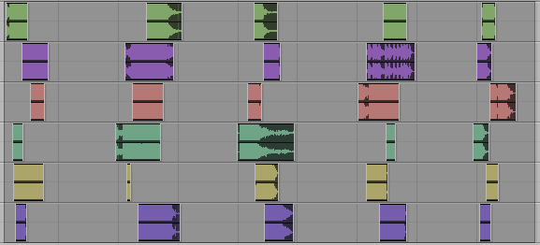
  - Each grouping of clips will be called a gesture.
  - The 5 gestures above will be called Gesture Set 1.
- Copy and paste Gesture Set 1 to the right, as shown below.
  - The gestures on the right will be called Gesture Set 2.
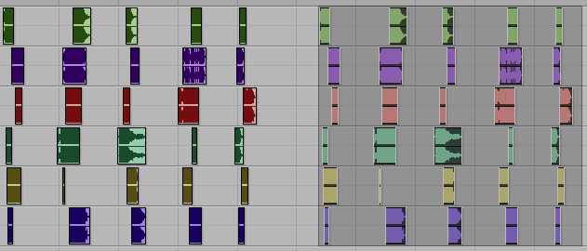
- Give each clip of Gesture Set 2 its own unique envelope (meaning, its own unique fade in and fade out).
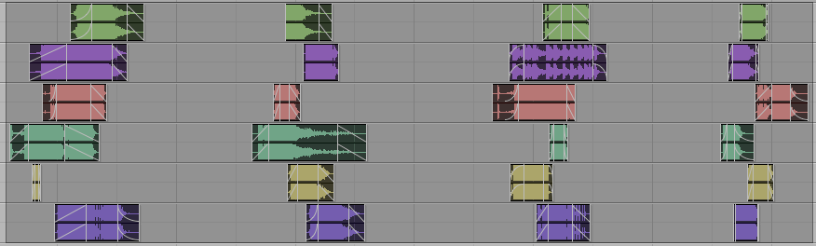
- Transpose the clips of Gesture Set 2 as follows:
  - Tracks 1-2 by +2 semitones
  - Tracks 3-4 by +4 semitones
  - Tracks 5-6 by -1 semitone
  - Alternatively, you could transpose by different intervals on any number of tracks. The goal is that the sounds from Gesture Set 2 are different from Gesture Set 1.
- Drag the individual clips in Gesture Set 2 to cyclically permute them as follows.
  - The clips in Track 1 rotate one space from right to left.
  - The clips in Track 2 rotate two spaces from right to left.
  - The clips in Track 3 rotate three spaces from right to left.
  - The clips in Track 4 rotate four spaces from right to left.
  - The clips in Track 5 stay in place.
  - The clips in Track 6 rotate one space from left to right.
  - When moving the clips, the precise placement of each one should be artistically made.
  - Steps a-g are shown below.

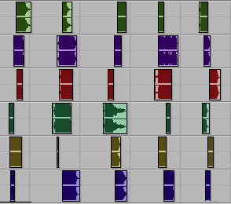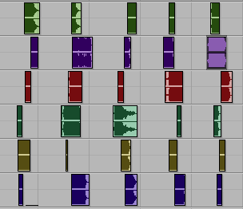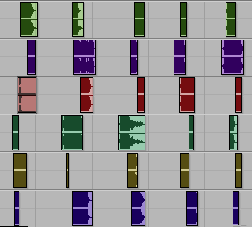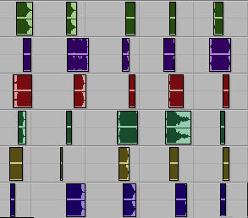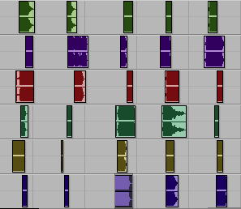
7a 7b 7c 7d 7f
- Create a new Gesture Set and repeat steps 3-6. Do this until you have used every gesture in Assignment 1.

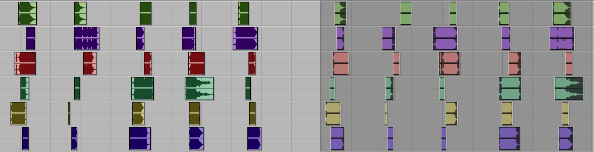
- Rhythmic ideas should be repeated multiple times in your Gesture Sets and should vary in each Gesture Set.
  - For example, on the first Gesture Set, suppose you choose 5 hits.
  - On the second Gesture Set, suppose you choose to have 8 hits. Make the overall rhythm slower than the first.
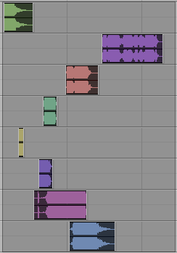
  - On the third Gesture Set, suppose you choose to have 11 hits. Start fast and then slow down halfway through the Gesture Set.
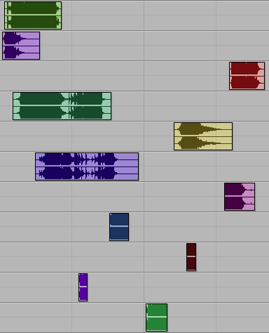
  - On the fourth Gesture Set, suppose you choose to have 13 hits. Begin slowly, and then accelerate towards the end of the Gesture Set.
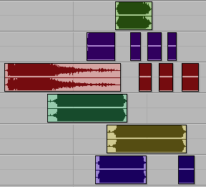
  - When controlling the rhythms of these Gesture Sets, the precise placement of your clips should be artistically made.
- If there is or any confusion or if any problems arise, set up a meeting with Jonathan and Carlos. You also have my permission to find an artistic solution to any problem that arises.

